**No of entities:**

* 1. Student entity
* 2. Enrollment entity
* 3. Course entity

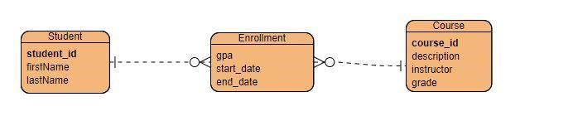

**No SQL data structure:**

{

"student_id" : ObjectID,

"firstName" : String,

"lastName " : String

}

{

"gpa": String,

"start_date" : String,

"end_date" : String,

"student_id" : ObjectID,

"Course_id" : ObejctID

}

{

"course_id" : ObjectID,

"description" : String

"instructor" : String,

"grade" : String

}